DML workshop 24/03/25 - Solutions

Questions on training and testing a Neural Network
You should be able to answer these questions. They also address common errors on the main task. Do not use ChatGPT, as this is an exercise in using notebooks and googling around to find basic descriptions. Knowing what terminology to use and how to phrase it is an important skill, and you can develop this by searching online yourself.
- What is the difference between parameters and hyperparameters?
[Free] Parameters are the weights and biases that change during training, whereas hyperparameters are architectural or training loop parameters that are set before training starts and usually remain fixed.
- Briefly describe/explain these hyperparameters
  - Learning rate – The step size that weights are updated by during backpropagation. Most modern optimisers have “adaptive” learning rates.
  - Epoch – An epoch is one full pass of all the training data through the network. 10 epochs means the network sees the whole dataset, 10 times.
  - Input/Output dimension – The input dimension matches the number of features input into the network. The output dimension matches the number of outputs you predict, so just one in our case.
  - Number of K-folds – The number of equal splits of training and validation data for cross-fold validation
  - Activation function – The non-linear function in each neuron that the input signal is processed through. Although, it does not have to be non-linear.
  - Batch size – The number of training points whose loss is averaged together before back propagation is performed.
  - Iteration (In the context of neural network training)
The number of times back propagation is performed
- What does a batch size of 1 and 10 mean?
A batch size of 1 means Backpropagation is performed for every single datapoint, whereas 10 means it is performed for the average loss of every 10 datapoints.
- For N training samples, what equation roughly estimates the number of iterations?
Iterations = (N / batch size) x epochs
I.e. If N = 20,000 and batch size = 5000 there are only 4 iterations per epoch.
If batch size = 1 there are 20,000 iterations per epoch, likely too many.
So somewhere in the middle is more appropriate.
What is wrong with the following code blocks? How might we fix them?
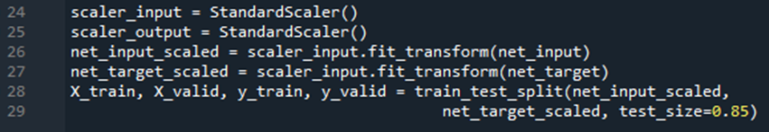
- These Lines have 2 or more errors
- The input scaler is used to scale the target data when it should be the target data. Furthermore, doing this overwrites the input scaler object.
- The split of validation data is 85% percent, when it should only be 5 to 20% of the total data.
- Scaling is done before splitting, which means data leakage can occur.
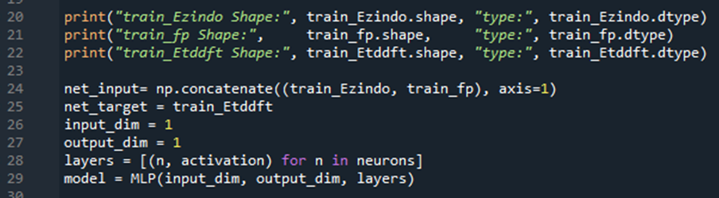
- These lines will cause one error.
This is Console output before the error is thrown:
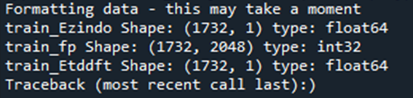
Input dim should be 2049 to match the number of features in net_input.
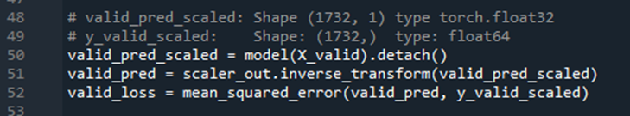
- There are three things wrong, but only one will throw an error. What are they? (The comments show the correct information of the two variables)
- The error will be thrown due to type mismatch (torch float versus numpy float).
- We shouldn’t mix scaled and unscaled data in the Mean Squared Error function. Either have both scaled, or both unscaled as they give different results.
- The shapes of both arrays in Mean Squared Error should be consistent
- What does .reshape(-1,1) do to numpy arrays?
(i.e. net_target = train_Etddft.reshape(-1,1))
Why/what might we need to use it for in the context of this workshop?
Say we have an array of 100 values. A normal numpy array shape is (100,) and applying .reshape(-1,1) or .reshape(len(myarray),1) recasts the array into a 2D $(N×M)$format, but the shape is $(N×1)$. So, its 1D data, but in a 2D array. Why do we do this? For some reason, when using np.concatenate, sklearns StandardScaler() or passing variables into Torch objects for training, an error gets thrown if it is not a 2D array. So this is just because the packages haven’t bothered accounting for it under-the-hood, probably for a specific reason.

